- Mouse cursor: shape manipulation tool (base button)
- “T”: text tool—inserts text into canvas
- Pen nib: pen tool—creates raster points for more shape tracing and graphic design (similar to Adobe Illustrator)
- Paint Brush: brush tool—only gives you one option for brushes
- Line: line tool—creates straight lines on the composition
- Square: square tool—creates squares and rectangles
- Circle: circle tool—creates circles and ovals
- Polygon: polygon tool—lets artist plot points to make customized geometric shapes
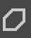
- Triangle: another polygon tool
- Curved line with arrows: Bezier line tool—creates organic shapes using vector points (similar to pen tool)
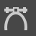
- Three points and two curved lines: Freehand path tool—creates organic shapes by drawing and connecting points.
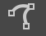
- Curve with dot in the middle: Dynamic brush tool—lightens up parts of the composition (like the dodge tool on Photoshop)
- Three brushes: multibrush tool—lets artist draw from all four coners of the canvas at once
- Four arrows: move tool—artist can move shapes after they’ve been cut
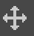
- Frame: crop tool—cut out parts of the composition
- Value scale: gradient tool—adds a gradient based on whatever part of the composition is selected
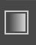
- Eyedropper: Color selection tool—selects specific colors on the composition that the artist can achieve
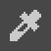
- Paint bucket: fill shape tool—fills selected shapes with one color
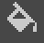
- All shapes with dotted lines are selection tools, including the magic wand
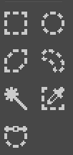
- Magnifying glass: zoom tool—zoom in and out of composition (pressing command minimizes it)
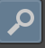
- Hand icon: pan tool—dragging composition across workspace
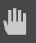
- On the right side, students will find a color wheel for color selection. The list of layers are right underneath it. However, because of the variety of transparencies for the brush presets, it’s possible for students to work on one layer if they feel comfortable.
- The eye icon (left) shows which layers are visible. Clicking the lock icon locks the layers, which means that it cannot be changed.
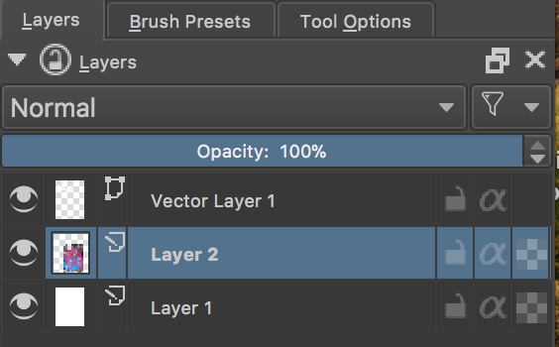
Discuss the brush presets (right hand bar, next to the layers tab). Demonstrate a few brush examples (see list below). Also explain that if students only work with just a mouse, they won’t get a lot of line and value varieties with pressure (similar to a pencil or paint brush).
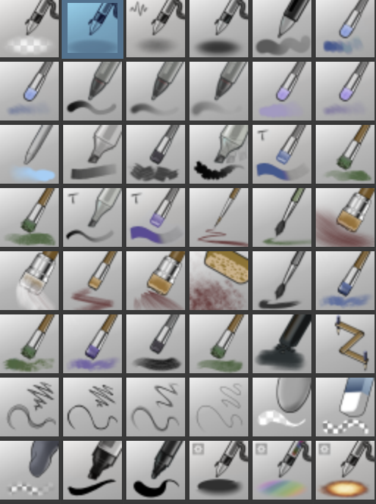
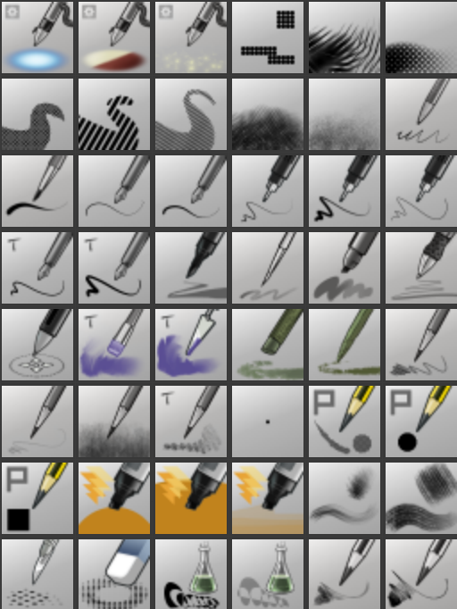
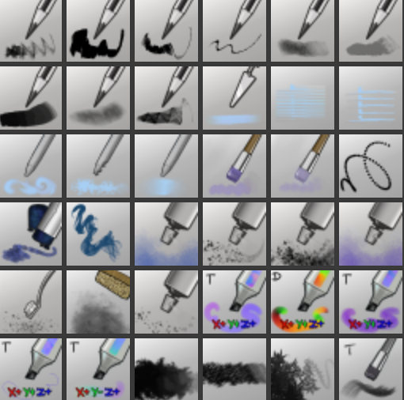
- Pen icons with a cord are airbrushes (lines with soft edges). Ones that don’t are regular pens (produce a thin line)
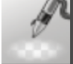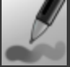
- Paintbrush icons create a blended line—colors blend with other colors on the composition.
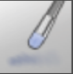
- Blending stump—blends two colors together
- Fat tip sharpie marker—creates large thick-thin marks
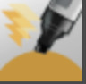
- Bristle brushes—create scratchy charcoal textures
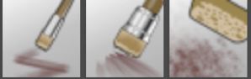
- Square, oval, and kneaded eraser with checkered pattern—erases lines
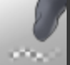
- FX brushes—creates special effects with stippling and drawing
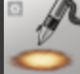
- Tones—create patterns similar to comic book art
- Rake smudge tools—pulls the color across the canvas
- Spray cans—create a spray paint texture.
- Pencil with a P next to it—pixel brush (creates lines that look like 8 bit video game imagery)
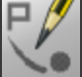
- Pencil tool—creates scratchy thick/thin lines similar to a pencil
Making custom brushes in Krita
- Select a new transparent layer and make marks with pre-selected brush tool.
- Use one of the select tools to draw around the marks
- Select brush tool on left hand tab and also click on brush tool with arrow on the top bar, on the left side.
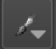
- Click brush tippre-defined tipstamp
- Name the brush and click “OK”
- Settings on the left-hand column affects lines and spacing.

